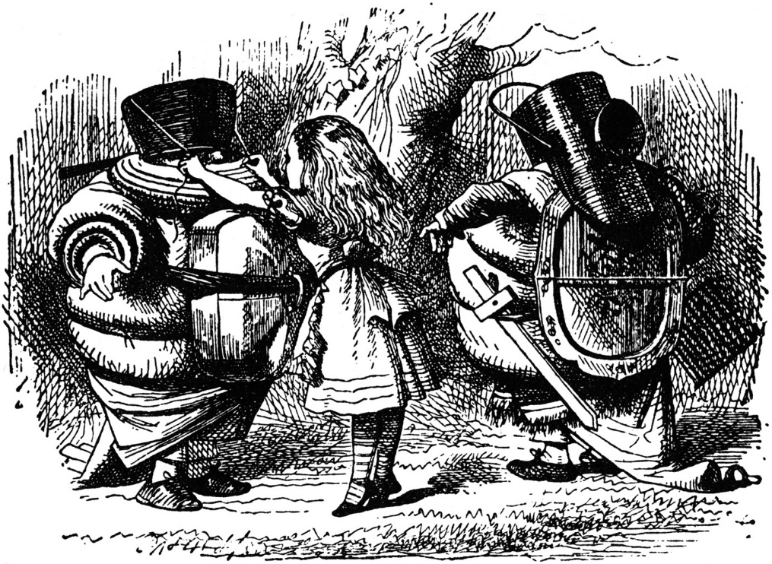

**Alice Engeström meets**

“Now you know, you are only being silly DUM. DEE is going to win,” said Alice ENGESTRÖM!

TweedleINGRAHAMdum

TweedleJONESdee