Open University TMA Essentials
By Rob Moore
Word Count: 968

Contents
Executive Summary 3
Formatting 4
Referencing 5
Diagrams 6
Recommendations 7
References 8
Appendix 1 – What goes into an appendix? 9

Executive Summary
A well-presented, well formatted and correctly referenced TMA is essential to score high marks for an Open University TMA.
To give TMAs the best chance of scoring high marks they need to be presented in the required format and always have a title page and contents page.
References are vital and need to conform to the Harvard Referencing style, to make sure this is correct the Open University guide to referencing should be worked through and used when writing TMAs.
Diagrams and models add value to TMAs only when they have been applied or adapted and are correctly referenced.
This short document is an example of how a TMA, suitable for use on a business studies course, might be laid out and presented.
Good luck moving forward and getting your TMAs better structured.
Rob

Formatting
Most TMAs tell you the format to apply to your TMA, whichever format your TMA should be presented in it is always a good idea to use a title page and a contents page as shown in this example. The guidance on TMAs suggests you use double spacing for your assignments, though with electronically submitted TMAs this is less important as we can use the comments features, always check with your tutor on their preference and if you have to submit a paper copy then double spacing makes life a lot easier.
The Open University has a lot of guidance on writing in different styles and for different purposes. These are found in the Study Skills section of the website, you can get to these from Student Home or you can follow this link: http://www2.open.ac.uk/students/skillsforstudy/index.php (Open University, 2013a)
Lots of really positive information on academic writing styles, study and exam techniques.
For the business related courses you are usually asked to produce a report, this will require you to use headings as I have here. Unless told to do so, avoid repeating the question or question numbers in your TMA.
There is a neat trick that helps you format your headings and create a contents list automatically, follow this link to a very short video that shows you the easy way to make contents pages:
http://youtu.be/DkqtHhqnOYo (MS Word - How to make Table of Contents Automatically, 2012)
To number your pages automatically you can follow the instructions in this short video:
http://youtu.be/eE2CDC5EdeQ (Page Numbering in Word, 2012)
Paragraphs are really useful in your TMA, no tutor wants to be faced by a wall of text, there is no strict rule on how long a paragraph should be but when you reach 10 lines you should be thinking about breaking up the paragraph into smaller ones.
An executive summary is required in formal reports. Executive summaries are not introductions, they are short summaries of the entire report. You should include all the key findings and conclusions of the report in a succinct way. It is very common for students to just give an introduction and call it an executive summary.
Here are the key differences:
Executive Summaries | Introductions
Give conclusions and recommendations | Talk about what is coming up
Give key facts | Do not give you conclusions or recommendations
Make sense if read on their own | Only make sense if you read the report following the introduction.
Read my executive summary for an example.

Referencing
You must reference your work correctly, failure to do so could have two consequences:
- You may not get the credit you deserve for using course theories and concepts, which may lead to you no passing the assignment.
- You could be accused of plagiarism, which is passing off someone else’s work as your own. There can be grave consequences for anyone found guilty of plagiarism.
We put a lot of time and effort into helping you with referencing. The Open University uses the Harvard Referencing style and even if you have used a different style effectively for years, you need to use this approach in your TMAs. Guidance on referencing is included in all course assignment guidance, but a more comprehensive guide is available at: http://learn1.open.ac.uk/mod/oucontent/view.php?id=2620 (Open University 2015). I strongly recommend you work through the pages of the web site here. Pay particular attention to:
- Section 4 “Secondary referencing”
- Section 7 “OU Module materials”
- Section 10 “Online/electronic materials”
The reference is made up of two parts, the in-text reference, which goes in the actual report and the references list or bibliography, which goes at the end of the report. The bibliography should be in alphabetical order.
Look at the referencing through this document. I have used the guide at the link shown to inform the referencing.

Diagrams
Diagrams and models can be an effective way of presenting your idea without using too many words. But keep in mind that the Open University does not reward your ability to draw a generic diagram or even worse, copy and paste a diagram from the course material.
Here are two examples of diagrams.
The first shows poor practice, a generic diagram copied form the course and not referenced. This would not score you any marks.
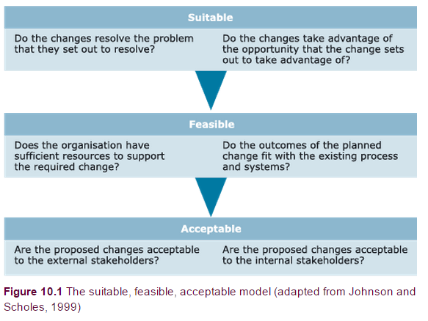
The second is the same diagram correctly referenced and applied and would earn a lot of marks.

The suitable, feasible, acceptable model applied to TMAs, based on Johnson and Scholes, 1999 cited in Open University (2013b)

Recommendations
The Open University is committed to helping students achieve the best they can and have produced a lot of guidance to help you.
Look for and use these resources.
You tutor will be able to guide you to find them and feel free to hunt them down yourself.
Look on student home for some really useful links.
In terms of business studies students, you won’t go far wrong if you follow the format of this document as a template for your TMAs and EMA.
Good luck.
Rob

References
MS Word - How to make Table of Contents Automatically (2012) YouTube video, added by oD142 [online]. Available at http://youtu.be/DkqtHhqnOYo (Accessed 8 February 2015).
Open University (2013a) Skills for OU Study [Online]. Available at http://www2.open.ac.uk/students/skillsforstudy/index.php (Accessed 8 February 2015)
Open University (2013b) 10.5 Choosing between/among change options [Online]. Available at https://learn2.open.ac.uk/mod/oucontent/view.php?id=522629&section=6 Accessed 8 February 2015)
Open University (2015) OU Harvard guide to citing references [Online] Available at http://learn1.open.ac.uk/mod/oucontent/view.php?id=2620 (accessed 8 February 2015)
Page Numbering in Word (2012) YouTube video added by Endsight [online]. Available at http://youtu.be/eE2CDC5EdeQ (accessed 8 February 2015)

Appendix 1 – What goes into an appendix?

The appendix should be used sparingly. It is there for supplementary material that is not essential to the report but gives background information.
The following would be acceptable things to put in an appendix:
- The questions from a questionnaire that is being summarised in the report.
- Company history that is not essential for the marker to understand the TMA but gives some additional context.
- A full analysis of a multi-step model where some of the steps are discussed but not all the steps.
- An extract from a letter or email that is being quoted from.
The following are not acceptable in the appendix.
- Full reports
- Long letters or emails
- Generic websites
REMEMBER: The appendix is not marked and you will not gain any marks for material in the appendix.
It is more than likely that the marker will not read the appendix, unless you have been asked to supply specific detail as an appendix.
The appendix should not contain more than three sides, unless you have been instructed to supply more as part of the task set.

