Are you Ready for S217?

Scientific Notation
The physics in S217 involves the use of very large and very small numbers. These are best expressed in scientific notation (the speed of light, for example, can be written as 3.0 × 10⁸ m s⁻¹) and this convention is used throughout the course.
- Express 200 000 000 in scientific notation.
- Express 95 × 10⁵ in scientific notation.
- Express $\frac{1}{1000000}$ in scientific notation.
- Express 0.000 33 in scientific notation.

Calculations, units, and significant figures
Studying S217 will require you to perform calculations using a scientific calculator, and in this section you will test your abilities at performing such calculations. Note that in all your calculations, it is important to use the appropriate units (such as m s−1 for velocity or N m−2 for pressure) when expressing your result, rather than giving only a number.
- Do the calculation 8.4 kg − 3.02 kg and express your answer in scientific notation, to the appropriate number of significant figures, and in the correct units.
- Do the calculation (2.394 × 103) m × (5.60 × 104) m and express your answer in scientific notation, to the appropriate number of significant figures, and in the correct units. (Press 'x' to represent the times symbol).
- Do the calculation $\frac{\left(7.642×{10}^{3}\right) kg}{2.82 m^{3}}$ and express your answer in scientific notation, to the appropriate number of significant figures, and in the correct units.

Algebra
Simple algebraic equations are used throughout S217. You should know how to rearrange equations to make a desired quantity the subject. Sometimes you will need to combine two expressions to make a third.
- If a car accelerates steadily along a straight road from an initial speed u up to a final speed v in time t, then the magnitude of its acceleration is $a=\frac{v-u}{t}$. Rearrange this equation to make the final speed v the subject of the equation (i.e. you should rearrange this equation into one that starts v = ...).
- Suppose that $x=\frac{2z^{2}}{a}$and $a=4zb$. Combine these two equations to give an equation for x that does not involve a.
- Combine the following two equations to give an equation for a which does not involve c
Equation 1
$a=bc$
Equation 2
$d=ce$
Give your answer in the simplest form and without brackets
- Rearrange $c=is^{2}+n$ to give an equation for s.
Select the correct answer from the options below.
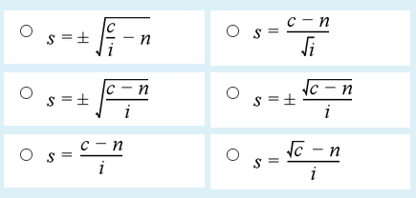
- Which two of the following expressions are equivalent?
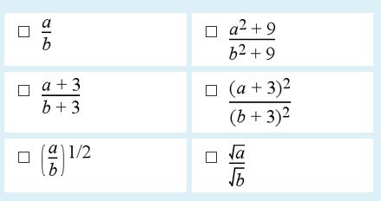
Squares and square roots
You will also need to know how to take squares (e.g. 22 = 4) and square roots (e.g. √2 = 1.414... ), using a calculator if necessary.
- Use your calculator to work out the square of 3.2.
Express the answer to the same number of significant figures as in the original number.
- Use your calculator to work out the square of 17.4.
Express the answer to the same number of significant figures as in the original number.
- Use your calculator to work out the square of 8.3.
Express the answer to the same number of significant figures as in the original number.
- Use your calculator to work out the square of 0.5.
Express the answer to the same number of significant figures as in the original number.
- Use your calculator to work out the square root of 80.
Express the answer to the same number of significant figures as in the original number.
- Use your calculator to work out the square root of 111.
Express the answer to the same number of significant figures as in the original number.
- Use your calculator to work out the square root of 1015.3.
Express the answer to the same number of significant figures as in the original number.
- Use your calculator to work out the square root of 0.5.
Express the answer to the same number of significant figures as in the original number.

Powers of quantities
You should be able to combine powers of quantities in both numerical and algebraic expressions.
- Simplify $\frac{x^{5}×x^{2}}{x^{3}}$
- Simplify $x^{-7}×x^{5}$
- Simplify $y^{-3}× \frac{y^{4}}{y^{2}}$
- Simplify $z^{\frac{1}{2}}×z^{2}$

Constants of proportionality
At several points in S217 you will be forming an algebraic equation from a proportionality by using a constant of proportionality.
- If y is proportional to x² ($y∝x^{2})$, give a simple equation relating y to x using a constant of proportionality, k.
- If y is inversely proportional to x² give a simple equation relating y to x using a constant of proportionality, k.

Trigonometry
Simple trigonometry, requiring the use of sines, cosines and Pythagoras' theorem, is used in S217. You should be able to solve problems involving triangles.
- Use your calculator to work out sin 60°, expressing your answer to two significant figures.
- Use your calculator to work out cos 60°, expressing your answer to two significant figures.
- Use your calculator to work out cos 30°, expressing your answer to two significant figures.
- Use your calculator to work out cos 145°, expressing your answer to two significant figures.
- For the triangle shown calculate the value of the quantities indicated.
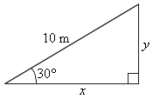
- For the triangle shown calculate the value of θ indicated.
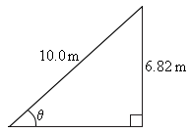
- For the triangle shown calculate the value of θ indicated.
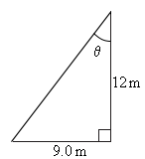
- For the triangle shown calculate the value of x indicated.
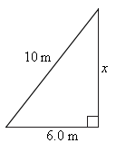

Graphs
You should be able to read graphs and extract numerical information from graphs. You should also be able to interpret graphs in terms of the mathematical relationship between the variables plotted, and to understand a graph as a visual representation of a mathematical function. You should be able to measure the gradient of a graph and use the value in calculations.
- If you were told that $y∝\frac{1}{x}$ , would you expect a graph of y against x to be a straight line?
Would it go through the origin?

- Look at the graph below. Which of the mathematical functions best describes this graph?
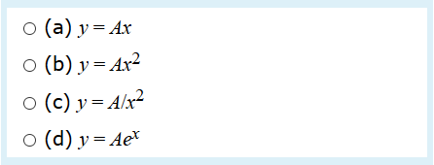
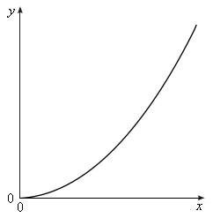
- The graph shows the distance s travelled by a vehicle against time t. Estimate the speed of the vehicle at time t = 12 s.
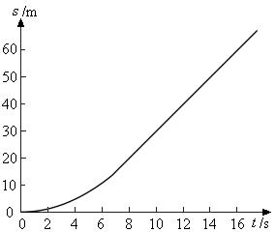
- $F{}_{z}$ and $z$ are related by the equation
$$F_{z} = –Kz$$where all the other quantities in the equation are constant.
What is the gradient of a graph in which $F_{z}$is plotted against $z$?
- $L$ and $ω$ are related by the equation
$$L=m r^{2}ω$$where all the other quantities in the equation are constant.
What is the gradient of a graph in which $L$ is plotted against $ω$?

- Given the following $F_{e}=\frac{Q_{1}Q_{2}}{4 πϵ_{0}R^{2}}$
where $F_{e}$ and R are variables, and $Q_{1},Q_{2}$ and $ϵ_{0}$ are constants.
Which one of the following graphs would be a straight line?
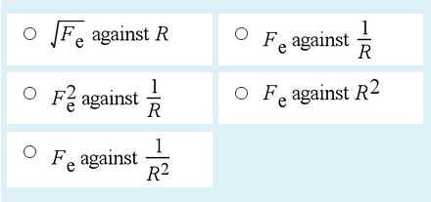

Answers
- 200 000 000 = 2 × 100 000 000 = 2 × 10⁸
- 95 × 10⁵ = 9.5 × 1 000 000 = 9.5 × 10⁶
- $\frac{1}{1000000}=1×{10}^{-6}$
- 0.000 33 = 3.3 × 10⁻⁴
- 8.4 kg − 3.02 kg = 5.38 kg
= 5.4 kg to 2 significant figures.
2 significant figures are appropriate here because in the question 8.4 kg is given to only 2 significant figures. It is inappropriate to give more than 2 significant figures in your answer in this case.
- (2.394 × 103) m × (5.60 × 104) m = 134064000 m² = (1.34 × 108) m² to 3 significant figures.
- 3 significant figures are appropriate here because in the question (5.60 × 10⁴) m is given to only 3 significant figures. It is inappropriate to give more than 3 significant figures in your answer in this case.
- Your answer is correct.
$a =(v - u)/t$,
so $v - u = at$,
and $v = u + at$.
- $x=2z^{2}/a$ and $a=4zb$
so $x=\frac{2z^{2}}{4zb}$
or x = $\frac{z}{2b}$
- We can start by rearranging Equation 2 to make c
the subject. Equation 2 can be reversed to give
$$ce=d$$Dividing both sides by e gives
$$c=\frac{d}{e}$$Substituting in Equation 1 gives
$$a=bc \\ =b×\frac{d}{e} \\ =\frac{bd}{e}$$
- 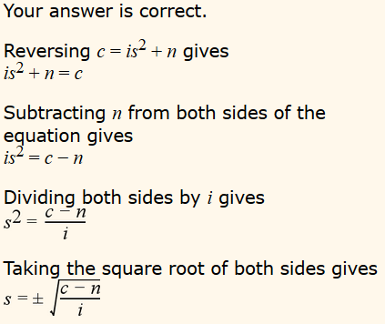
- 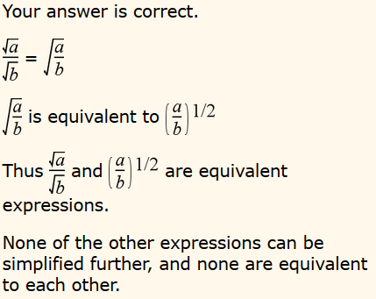
- 3.2² = 10 (2 significant figures)
- 17.4²= 303 (2 significant figures)
- 8.3² = 69 (2 significant figures)
- 0.5² = 0.3 (1 significant figures)
- $\sqrt{80}=8.0$ (2 significant figures)
- $\sqrt{111}=10.5$ (3 significant figures)
- $\sqrt{1015.3}=31.864$ (5 significant figures)
- $\sqrt{0.5}=0.7$ (1 significant figure)
- 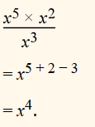
- 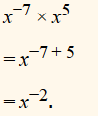
- 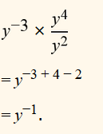
- 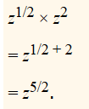
- $y=kx^{2}$
- $y=\frac{k}{x^{2}}$
- $\sin{60°=0.87}$
- $\cos{60°= }$0.50
- $\cos{30°=0.87}$
- $\cos{145°= -0.82}$
- x = 10 m × cos 30° = 10 m × 0.8660... = 8.7 m to 2 significant figures.
y = 10 m × sin 30°= 10 m × 0.5 = 5.0 m to 2 significant figures.
- θ = arcsin (6.82 m/10.0 m) = 43.000...° = 43.0° to 3 significant figures.
- θ = arctan(9.0 m/12 m) = 36.86...° = 37° to 2 significant figures.
- x² = (10 m)² − (6.0 m)² = (100 − 36) m²
so x = $√(64)$ m = 8.0 m to 2 significant figures.
- Since $y∝\frac{1}{x}$, a graph of $y$ against $x$ would not be a straight line. (Note, however, that a graph of $y$ against $1/x$ would be a straight line.)
A graph of $y$against$x$would not go through the origin: $y =∞$when $x = 0$.
(A graph of $y$ against $\frac{1}{x}$ would go through the origin: $y = 0$ when $\frac{1}{x}=0.)$
- 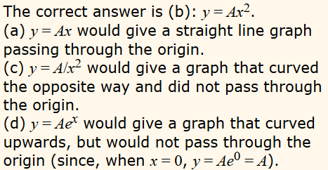
- At time t = 12 s the speed of the vehicle is constant (since the graph is a straight line at this point).
The speed is given by the gradient of the graph which is about $\frac{40 \text{m}}{8 \text{s}}=5 \text{m }{\text{s}}^{\text{-1}}$
- If $y = kx$ then a graph of $y$ against $x$ is a straight line with gradient $k$.
In this case $y = F_{z}$ and $x = z$, so the gradient of a graph of $F_{z}$ against $z$ is $–K$.
- If $y = kx$ then a graph of $y$ against $x$ is a straight line with gradient $k$.
In this case $y = L$ and $x =ω$, so the gradient of a graph of $L$ against $ω$
is $mR^{2}$.
- $F_{e}$ is inversely proportional to $R^{2}$2
i.e. $F_{e}$ is proportional to $1/R^{2}$
so $F_{e}$ against $\frac{1}{R^{2}}$ will be a straight line.

